

SYNOPSIS

**ON**

**AI Bot To Play Tic-Tac-Toe**

Submitted By : Submitted To: **Mr. Amir Khan**

Suyash Kumar- K- 2115001025 Mentor Name: **Mr. Amir Khan**

Ashutosh Singh- H- 2115000235 Designation: **Asst. Professor**

Deepansh Niranjan- I - 2115000324 Department: **CEA**

Divyam Upadhyay- I - 2115000377

**Title of the Project:**

Artificial Intelligence Bot to play Tic-Tac-Toe.

**Objective:**

The objective of creating a Tic-Tac-Toe-playing AI using the minimax algorithm is to demonstrate how AI can make intelligent decisions in a simple two-player game. This project serves as an educational and illustrative example of AI decision-making in a deterministic, zero-sum game.

**Scope:**

**In Scope:**

**Game Logic**: It covers the logic required to check for game-winning conditions, detect a draw, and ensure that players make valid moves.

**AI Implementation:** The project implements an AI using the minimax algorithm, allowing the AI to make optimal moves and providing a challenging opponent for the human player.

**User Interface:** The project includes a simple text-based user interface to display the game board and gather player moves.

**Future Scope:** The future scope of AI includes increased automation in various industries, transformative impacts on healthcare, advancements in autonomous vehicles, improved natural language processing, applications in finance and education, enhanced cybersecurity measures, contributions to addressing climate change, improvements in entertainment. Overall, AI is expected to play a pivotal role in shaping the future across diverse sectors of society.

**Limitations:**

**Predictability:** The game has a limited number of possible moves, and with optimal play, it often leads to a predictable outcome (either a win for one player or a draw). This lack of variability can make the game less interesting for experienced players**.**

**Small Game Tree:** The game tree, representing all possible moves and outcomes, is relatively small. This simplicity means that computers can easily analyze all possible moves and outcomes, making it possible to create unbeatable AI opponents.

**Memorizable Patterns:** Since the game is simple, players can memorize winning and blocking patterns. This reduces the reliance on strategic thinking and adaptability during gameplay.

**Methodology:**

Used Python Programming Language , Jupyter Notebook

**Proposed System:**

We are developing an AI bot to function like another player. The core idea behind this project is the use of AI, this project will help us know better about how AI functions, its various uses in other industries which can vastly affect our lives and make it easy.

**Features:**

**The key features and functionalities of the Tic-Tac-Toe AI project include:**

**Player vs. AI:** A mode where a human player (X) can play against a computer-controlled AI opponent (O).

**AI Minimax Algorithm:** The AI opponent employs the minimax algorithm to make optimal moves, ensuring a challenging and intelligent opponent.

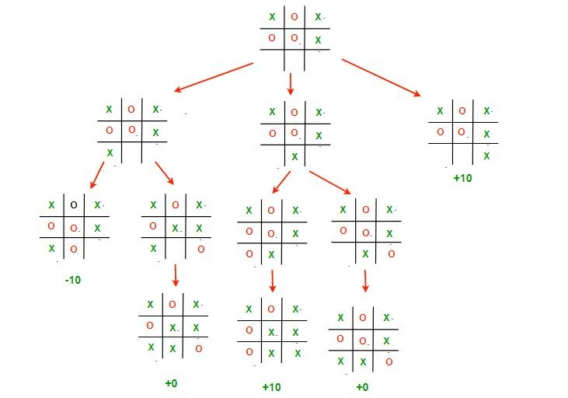

**User Input:** The human player can interact with the game by specifying their moves on the grid using row and column coordinates.

**Outcome Determination:** The game announces the winner if a player achieves three in a row or declares a draw if all cells are occupied without a winner.

**Optional Features (Enhancements):** Depending on the project's scope, potential optional features could include a graphical user interface (GUI), different board sizes, difficulty levels, or a multiplayer mode.

**Implementation Plan:**

**Project Initiation**

Define project objectives and scope.

Set clear milestones and deadlines.

Create a project plan.

**Implementation**

Code the game logic, including board setup, player moves, AI behavior, and outcome determination.

Implement the minimax algorithm for AI decision-making.

Develop the user interface for displaying the game board and gathering user input.

**DFD :**

Tic-tac-toe is a computer game in which a human player and the computer

make alternative moves on a 3×3 square. A move consists of marking

previously unmarked square. The player who first places three

consecutive marks along a straight line on the square (i.e. along a row,

column, or diagonal) wins the game. As soon as either the human player

or the computer wins, a message congratulating the winner should be

displayed. If neither player manages to get three consecutive marks along

a straight line, but all the squares on the board are filled up, then the

game is drawn. The computer always tries to win a game.

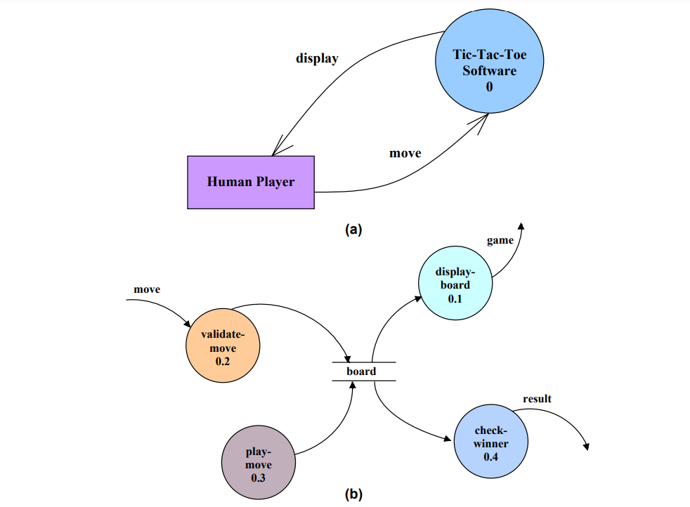

**Team Members:**

Suyash Kumar

Ashutosh Singh

Deepansh Niranjan

Divyam Upadhyay

**References:**

* wikipedia.org
* ChatGPT
* Geeksforgeeks.org
* w3schools.com
* github.com
* youtube.com

**Expected Outcomes:**

**Playable Tic-Tac-Toe Game:** A functional and interactive Tic-Tac-Toe game that adheres to the classic rules and gameplay, providing users with an engaging gaming experience.

**AI Intelligence:** A challenging AI opponent that consistently makes intelligent decisions to win the game or force a draw, demonstrating the capabilities of the minimax algorithm

**Project Supervisor:**

Mr. Amir Khan

**Conclusion:**

The Tic-Tac-Toe AI project has successfully delivered a fully functional and user-friendly game that allows players to engage with a challenging AI opponent using the minimax algorithm. The project encompasses classic Tic-Tac-Toe gameplay, AI intelligence, a user-friendly interface, correct game logic, optional features, testing, and the potential for future maintenance and updates. It serves as an educational and entertaining demonstration of AI in a gaming context.